|  |
| --- |
|  |
| Fotoball |
|  |
| CSC509: Conceptual Models |

April 6, 2015  
Authored by: David Cipoletta, AbrAhAm Herrera, Adam Jilling, Rick Rejeleene

Version: 1.2

June 4, 2015

Authored by: David Cipoletta, AbrAhAm Herrera, Adam Jilling, Rick Rejeleene

Rev 1.0

Fotoball

CSC509: Conceptual Models

Contents

Overview Model 2

Hardware Conceptual Model 3

Software Conceptual Model 4

LEGEND 5

### Overview Model

The following represents the overall flow of the system. From the Fotoball hardware, to the users mobile device, to the internal database.

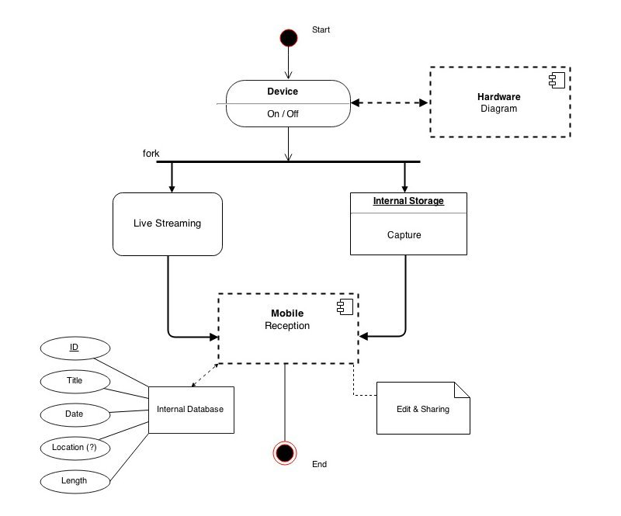

### Hardware Conceptual Model

Basic flow of the hardware system showing which components will connect to which other components.

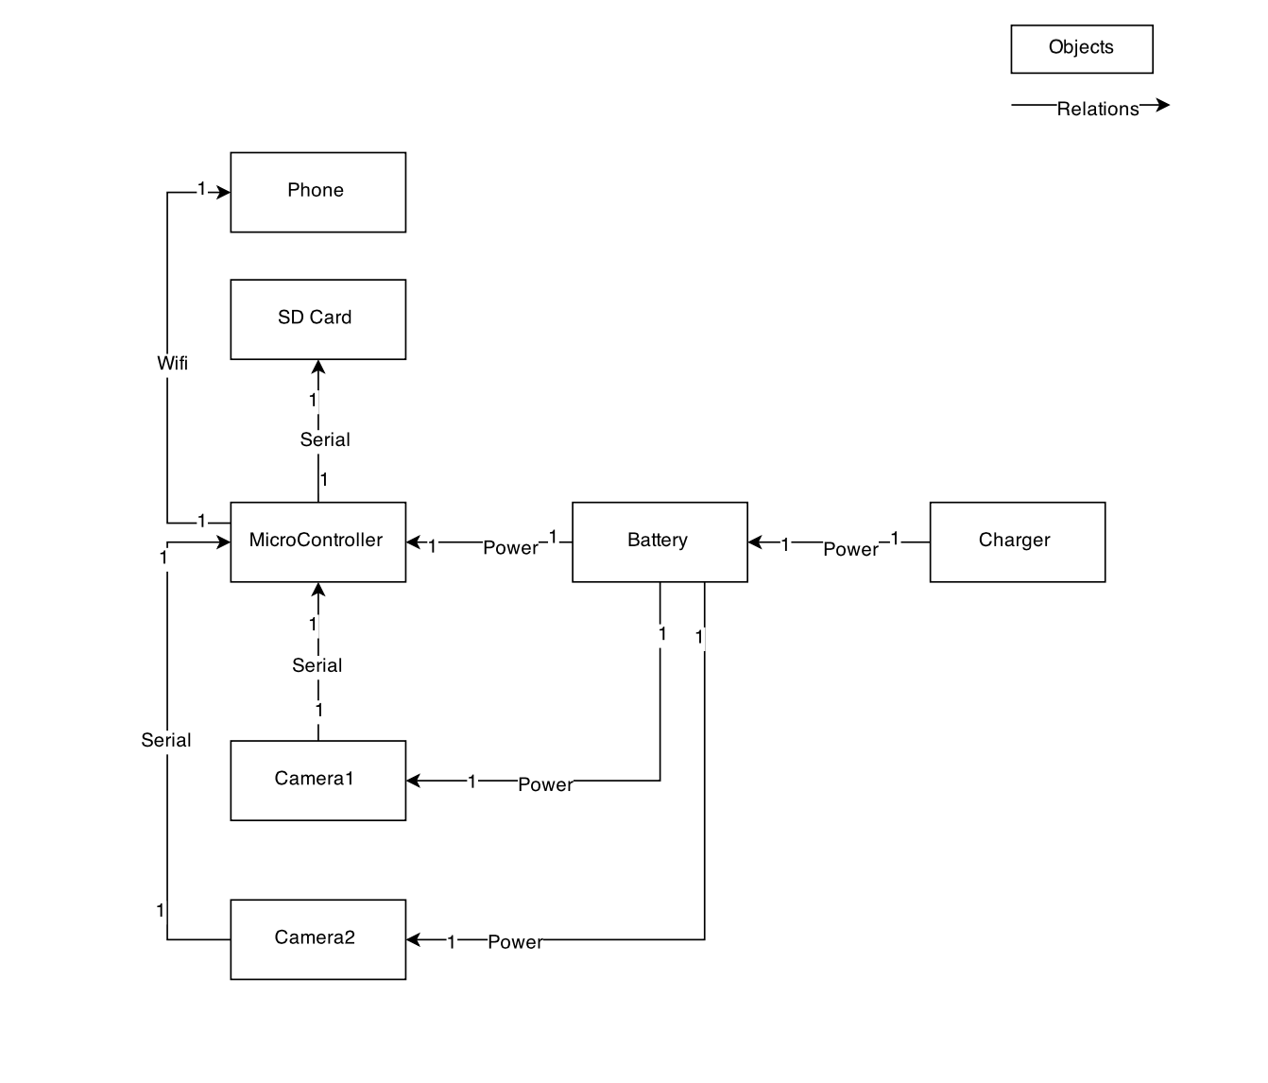

### Software Conceptual Model

The main classes and views that make up the application are shown here, with each class’s objects represented in the middle and each class’s major methods represented in the bottom.

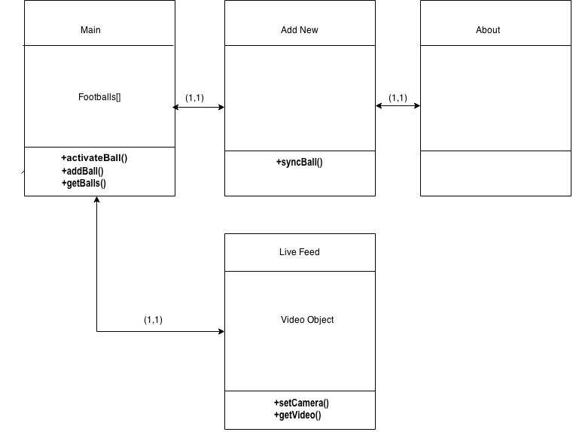

### 

### LEGEND

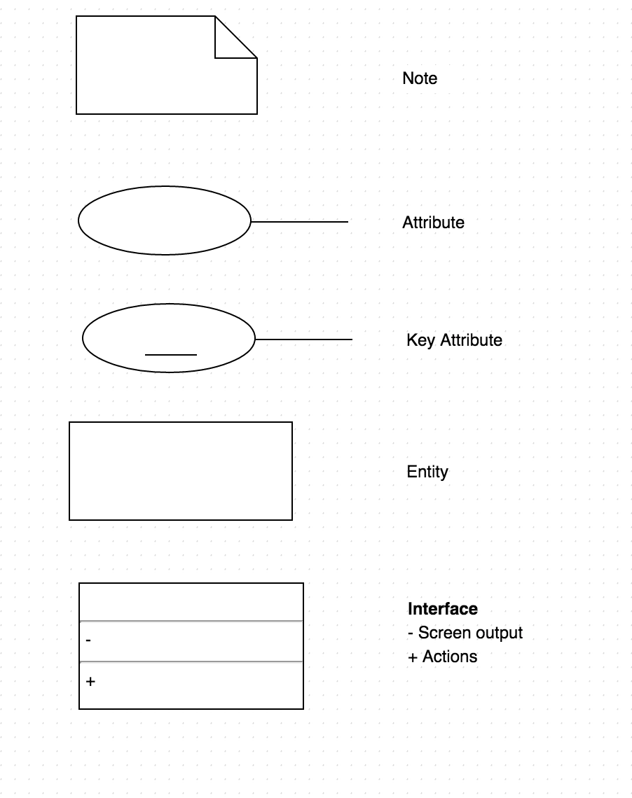

### ::Screenshots:Screen Shot 2015-03-02 at 6.46.30 PM.png